**Project: Sales Insights Dashboard using TABLEAU**

**Analysis in SQL**

Imported the file to SQL

1. Data Exploration:

SELECT count(*) FROM sales.customers;

SELECT count(*) FROM sales.transactions;

SELECT * FROM sales.products;

SELECT * FROM sales.markets;

SELECT count(*) FROM sales.transactions where market_code="MARK001";

1. We found there are some inconsistencies in this data.

Example: In sales_amount, it has -1 value. In currency column, it has USD.

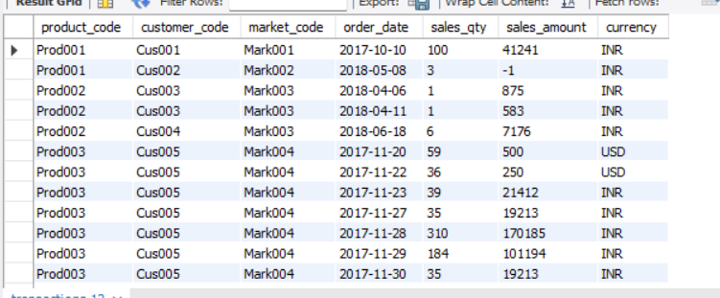

3. Data exploration using SQL queries

**Q) Show transactions where currency is US dollars**

**SELECT * FROM sales.transactions WHERE currency=”USD”;**

Output: 2 rows only.

|  |
| --- |
|  |

We can convert these two USD rows into INR while building a model in Tableau.

**Q) Show transactions in 2020 join by date table**

We are performing inner Join with transactions table and date table.

**SELECT sales.transactions.*, sales.date.* FROM sales.transactions INNER JOIN**

**sales.date ON sales.transactions.order_date=sales.date.date where**

**sales.date.year=2020;**

|  |
| --- |
|  |

**Q) Show total revenue in year 2020**

**SELECT SUM(sales.transactions.sales_amount) FROM sales.transactions INNER JOIN sales.date ON sales.transactions.order_date=sales.date.date where sales.date.year=2020;**

Output:

'142235559'

In 2019, it is '336452114'

We can infer that sales are declining from 2019 to 2020.

**Q) Show total revenue in year 2020 in Chennai**

**SELECT SUM(sales.transactions.sales_amount) FROM sales.transactions INNER JOIN sales.date ON sales.transactions.order_date=sales.date.date**

**where sales.date.year=2020 and sales.transactions.market_code="Mark001";**

Output: '2463024'

**TABLEAU**

Connected SQL database to Tableau.

Creating a data model (It is the process of converting different tables and establishing a relationship. It is also known as **star schema**.)

A star schema is a multi-dimensional data model used to organize data in a database so that it is easy to understand and analyze. Star schemas can be applied to data warehouses, databases, data marts, and other tools. The star schema design is optimized for querying large data sets.

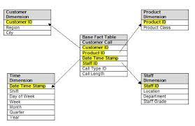

We will create a data model for our data base (as shown in the below fig)

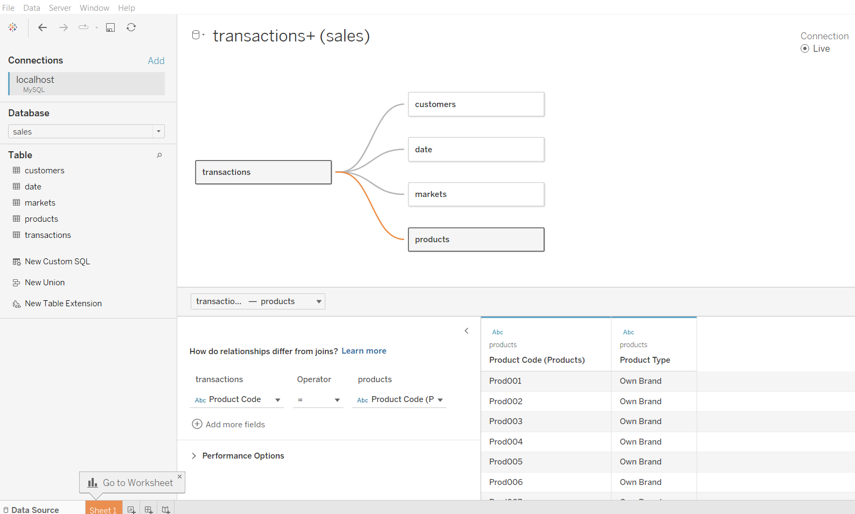

Now, we will do data cleaning through ETL (Extract, transform, and load)

Extracting data from Mysql, transforming it and loading it into Tableau to build dashboard.

1. Checking all the columns in the transactions table using sort option.
2. In sales amount column in transactions table, there are some records which have -1 and 0, which is not correct.

Process for removing those values:

Data > Edit filter > Sales amount > Range values = 1

It will filter out those values.

1. In markets table, there are two records which has New York and Paris. I have to filter out those records as this database has only Indian market data.

Data > Edit filter > Market code > Select all and uncheck 097, 099 codes cells > Ok

1. Converting all values in the Currency column into INR.

For that sales column > calculated field > name > formula set up

**IF [Currency] == 'USD' THEN [Sales Amount]*74**

**ELSE [Sales Amount] END**

**DASHBOARD BUILDING**

Now, we are building individual widgets in separate sheets. Then, we will club all the widgets and add it to dashboard.

Ctrl + shift + B = to increase the size of graph in tableau

Ctrl + B = to reduce.

**Widgets created**

* Year card
* Month card
* Total Revenue
* Sales quantity
* Revenue by year
* Revenue by markets
* Sales Qty by markets
* Top 5 customers
* Top 5 products

**Dashboard – Revenue Analysis built as shown in the below picture**

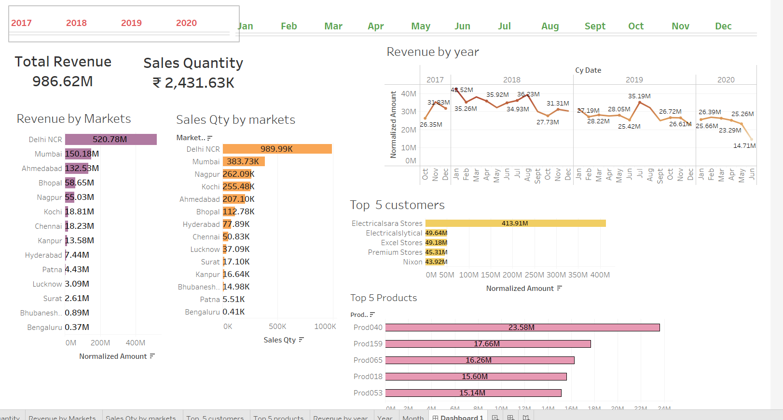

* Contextual filter
* Imported another SQL file which has Profit, and profit margin
* Building widgets of profit analysis
* For profit margin by markets, created a calculated field:

SUM([profit_margin])/SUM([Normalized Amount])

* Profit trend chart

Added revenue (Normalized amount column) and profit margin % (calculated field) columns in rows

Cy date in Columns

**Dashboard – Profit Analysis**

